

ROLL UP DOOR
LOW PROFILE HANDLEBAR
INSTALLATION INSTRUCTIONS

***READ ALL INSTRUCTIONS BEFORE ATTEMPTING INSTALLATION OF YOUR ROLL UP DOOR PRODUCT***

DOC NO: INST00018
DATE: November 5, 2025
TABLE OF CONTENTS
INTRODUCTION 3
SECTION 1 – Basic Installation 3
Step 1 – Mounting Plate / Bottom Sill Installation 3
Step 2 – Roller Tube Installation 6
Step 3 – Curtain Installation 7
Step 4 – Handlebar Installation 10
Step 5 – Guide Channel Installation 15
Step 6 – Drip Rail Installation 17
Step 7 – Final Assembly 21
SECTION 2 – Optional Features 23
Door Ajar Switch 23
Bungee Strap 24
10mm LED Compartment Lights 25
Drip Pan 28
Lit Handlebar 29
SECTION 3 - Care and Maintenance 35
APPENDIX A - Drip Pan Drilling Guide 36
APPENDIX B – Slide Guide Removal Procedure Error! Bookmark not defined.

INTRODUCTION
This document provides a step-by-step guide to installing your rollup door and associated accessories. The required tools and recommended safety equipment are listed below:

Tools Required:
- Drill with bits (including 1/8", 3/8")
- Screwdrivers (Phillips and flathead)
- Pliers (needle-nose recommended)
- Carpenter’s Square
- Measuring tape
- Level
- Wax pencil or masking tape
- Soft mallet or block of wood

Recommended safety equipment:
- - Safety glasses
- - Protective gloves
- - Closed-toe footwear
- - Hearing protection (if using power tools)

Fasteners and wiring protection (if applicable) are not included. The recommended fasteners are listed below:

- #10 sheet metal screws (for mounting plates)
- #8 sheet metal screws (for guide channels and drip rail)
- 3/16" self-tapping fasteners (for drip pan brackets)
- Screws (for bungee strap bracket)
- Split sheathing (for wire protection)

SECTION 1 – Basic Installation

Step 1 – Mounting Plate / Bottom Sill Installation
The arrows stamped in the roller tube mounting plate sub-assemblies should be aligned with the top of the compartment opening, and the front edge of the plate spaced 1-3/4” back from the front face of the vehicle body as shown. It is recommended to use a carpenter’s square or other right-angle tool to lay out a wax pencil line or tape line for this. (See Figure 1)

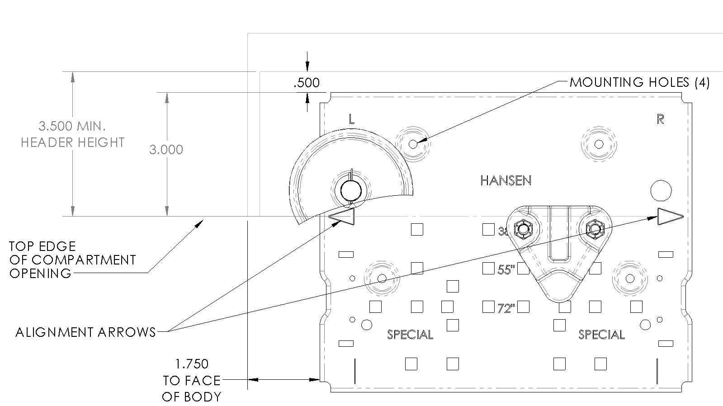
Figure 1 - Roller tube mounting plate installation
With the plate held in position, mark the four mounting hole locations on the compartment side wall. Drill one hole and secure the mounting plate with a #10 sheet metal screw or other fastener suitable for the material and thickness of the body. The head of the fastener must not protrude above the face of the mounting plate or the curtain could hit it as the door rolls up. Use the mounting plate as a drill guide to drill the remaining three holes. Note that the left and right side compartment walls must be flush with the left and right edges of the compartment opening; otherwise, the mounting plates will have to be shimmed up until the underside of the mounting plates are flush with the compartment edge.
Repeat this process for the other roller tube mounting plate on the other side of the compartment.
If your door does not include the optional bottom sill, the following step may be skipped. Otherwise trim the rubber side seals at the bottom of the guide channels and test fit them in the aperture of the body (keeping each of the guide channels firmly pressed against the compartment wall, make a small pencil or tape mark on the left and right side edge of one of the guide channels to locate the edges of the bottom sill).
Remove the guide channels from the opening and peel the backing from the double-sided tape on the bottom of the sill. Taking care to center it between the pencil marks (the sill might be slightly wider or narrower than the pencil marks depending on your apertures width tolerance), adhere the sill to the bottom of the compartment opening as shown, pressing firmly down on the tape to secure it to the body. A small drilling groove is provided to utilize additional fasteners (not supplied) for the sill if desired. (See Figure 2)

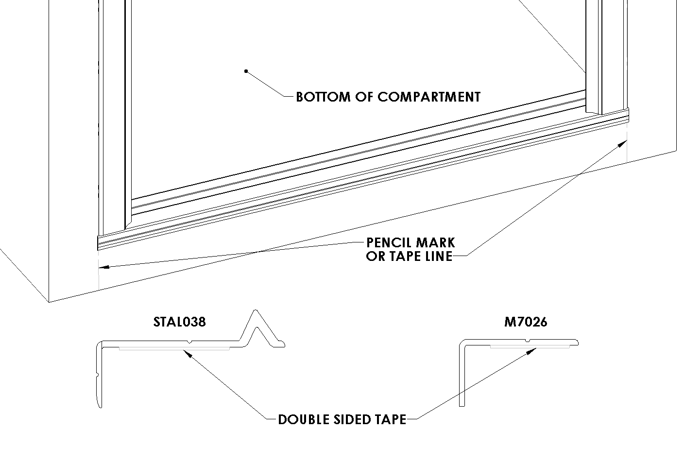
Figure 2 – Bottom sill installation

Step 2 – Roller Tube Installation
Install the roller tube between the pre-positioned cradles on the mounting plates with the straps facing forward. Secure the roller tube shaft in the cradles on both sides with the cotter pins supplied with the mounting plates. Do NOT remove the spring retaining pin passing through the roller tube shaft on the left side of the roller tube sub-assembly at this time. The roller tube is under spring tension, and this pin maintains that tension until the door curtain is installed. (See Figure 3)

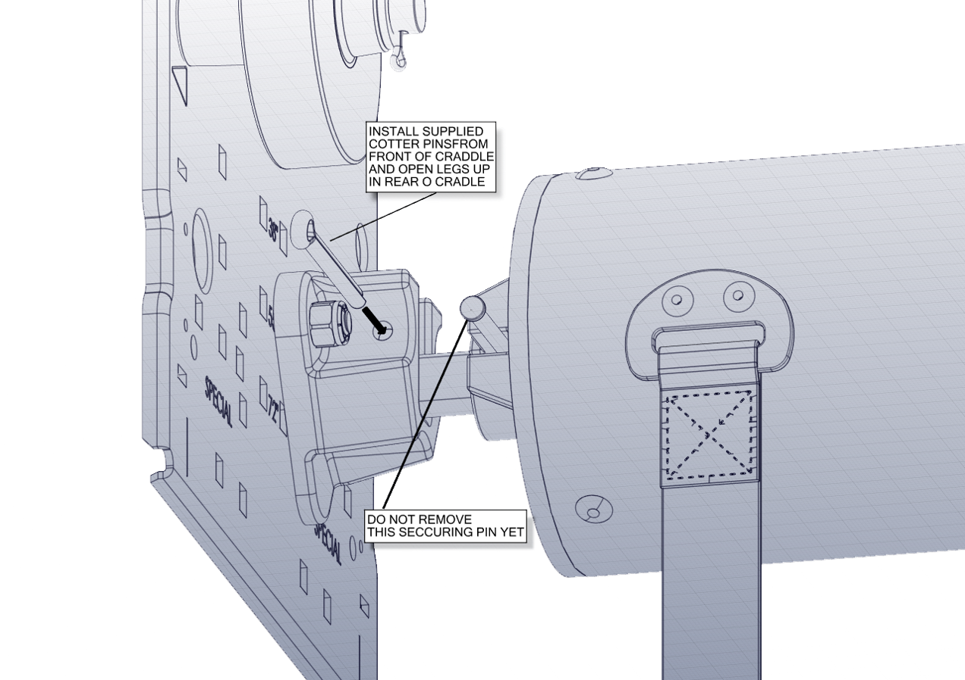
Figure 3 - Securing roller tube

Step 3 – Curtain Installation
Slide the top of the curtain through the top of the compartment opening and over the top of the curtain roller wheels on the mounting plates as shown. Notice the brackets riveted to the top of the curtain denote the edge of the curtain to be fed into the compartment. (See Figure 4)

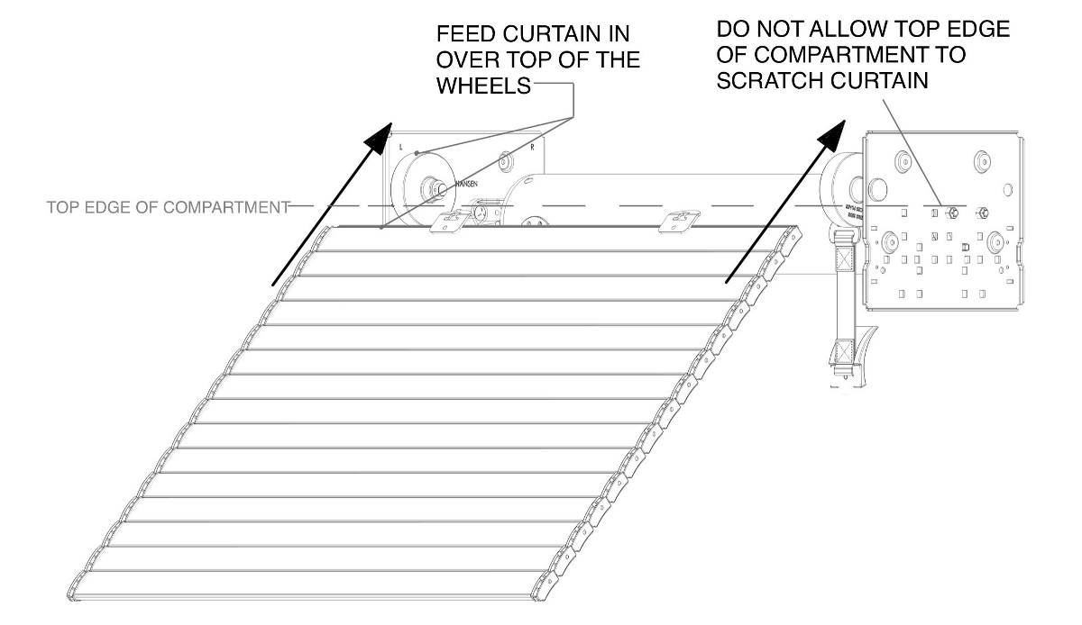
Figure 4 - Initial curtain installation
Note that your Roll Up Door may come with more than two roller straps. The straps you receive will be longer than those shown in Figure 4. Before proceeding, wrap the straps around the back of the roller tube so they have a resting position as is shown in Figure 5.

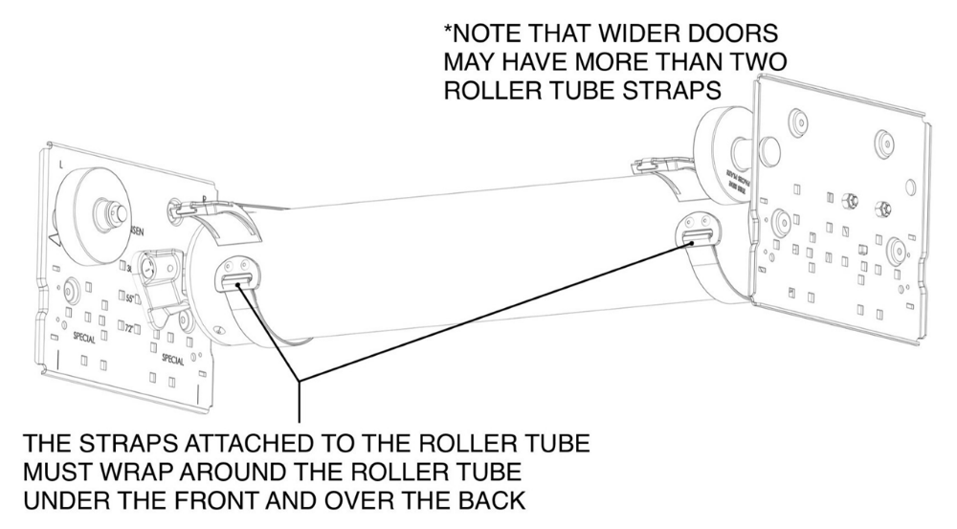
Figure 5 - Roller tube installation
Continue to feed the curtain over the top of the roller tube as shown in Figure 6, until enough has drooped over the back of the roller tube to expose the curtain brackets and hold the handlebar at the top of the compartment.

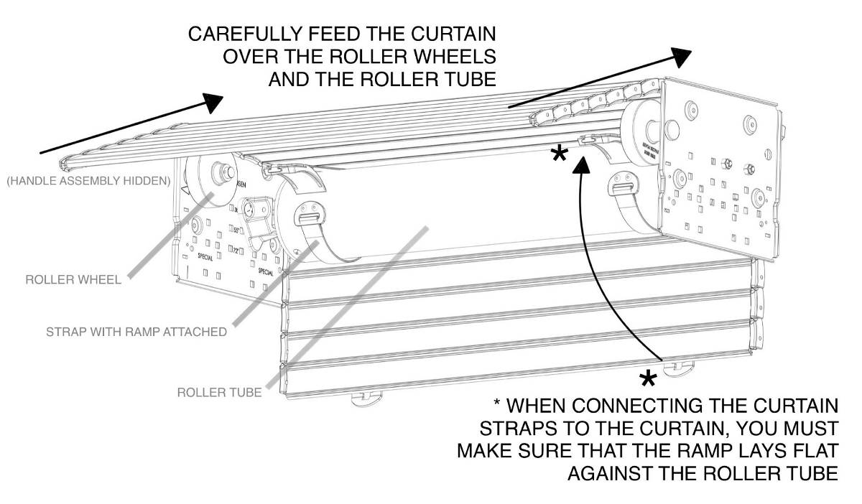
Figure 6 - Feed curtain over top of wheels and tube
Hook the male brackets on the strap into the female brackets riveted to the top of the curtain as shown in Figure 7. Allow the straps to wrap around the back of the roller tube.
For large doors it may be helpful to have one installation technician inside the compartment to attach the straps while one or two others feed the curtain over the top of the roller wheel and roller tube:

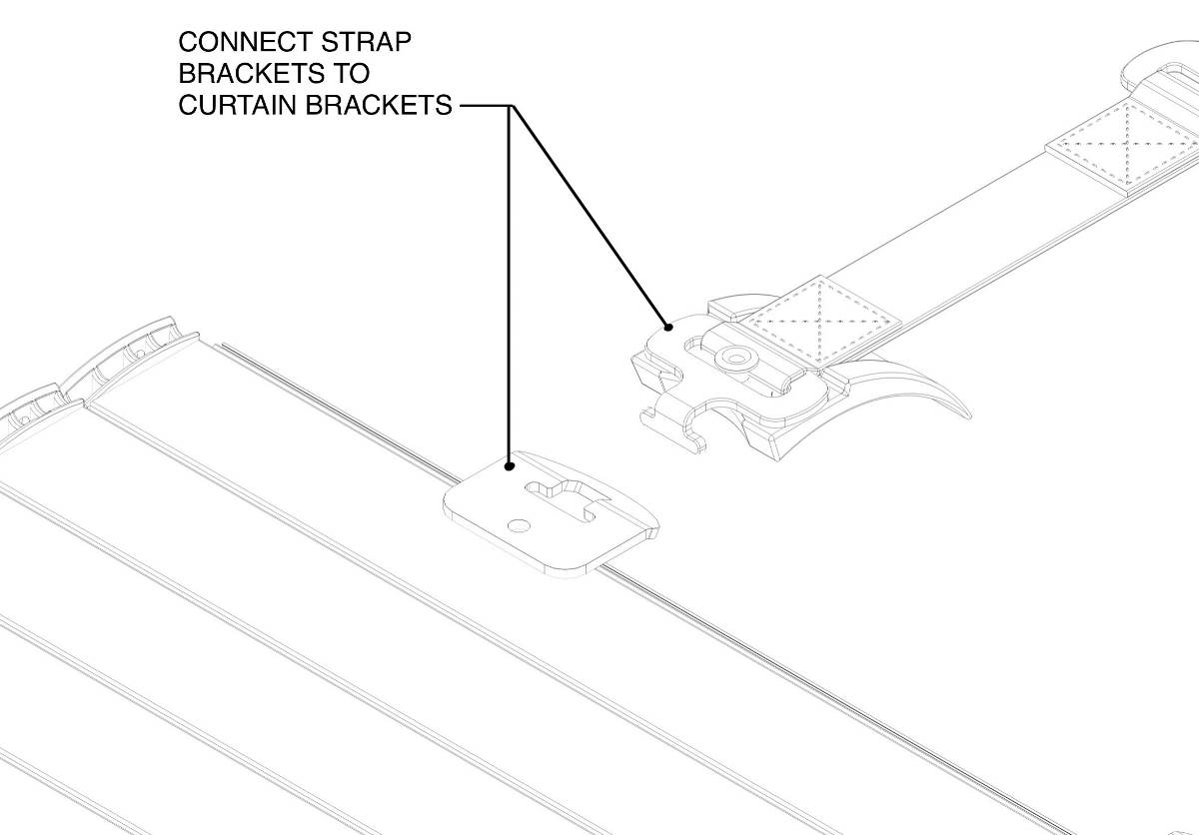
Figure 7 - Attach roller tube straps to curtain brackets

Step 4 – Handlebar Installation
The handlebar is shipped detached from the curtain and will need to be connected after the curtain is hung.

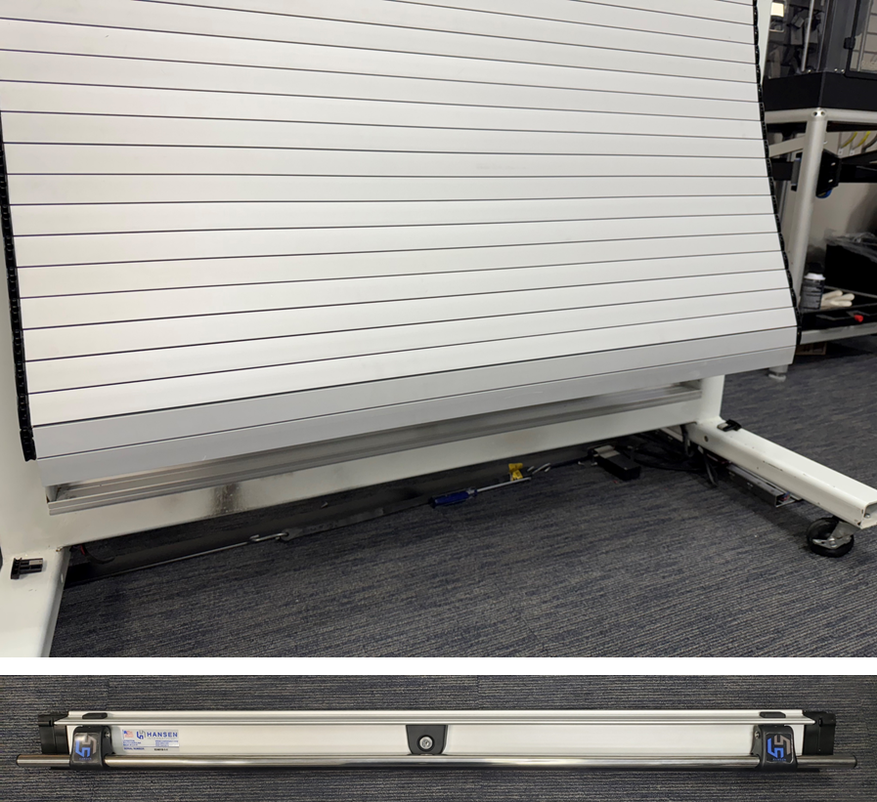
Figure 8 - Curtain and handlebar shipped detached
The socket on the bottom of the adapter lath contains an extruded insert (Figure 9). Be sure it is present inside the socket and does not slip out.

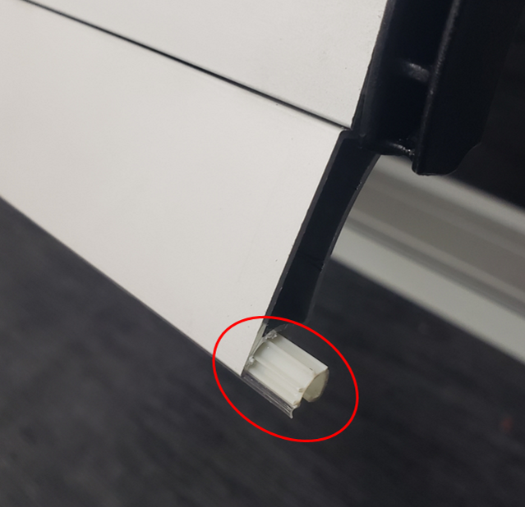
Figure 9 - Adapter lath with extruded insert in the socket
Slide the ball (a) of the handlebar into the socket insert (b) on the adapter lath on the bottom of the curtain as shown in Figure 10, being sure not to push the insert out in the process. Note that the handlebar can be connected to the curtain from either side.

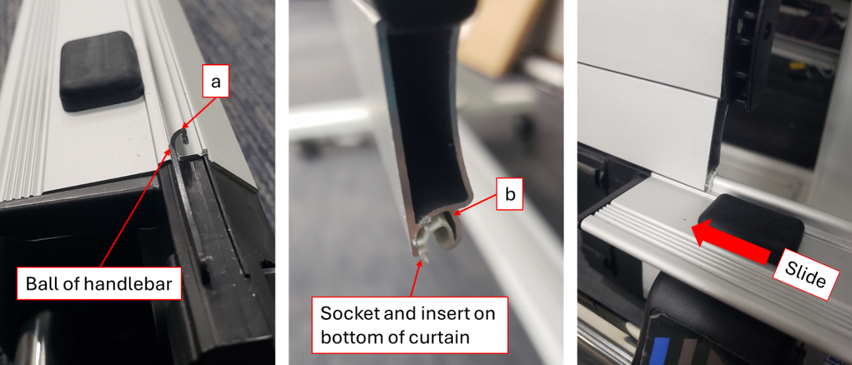
Figure 10 - Slide the handlebar onto the bottom of the curtain
Slide the handlebar onto the curtain until centered.

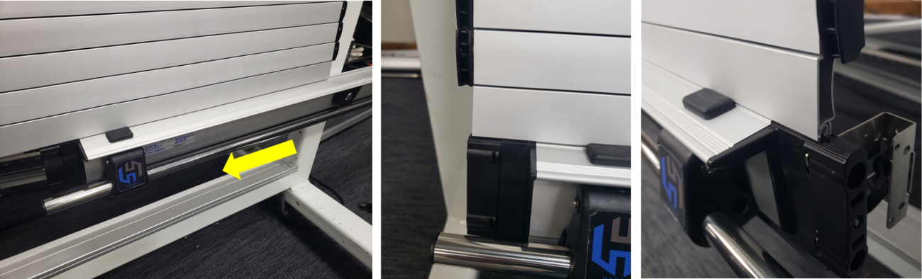
Figure 11 - Handlebar fully inserted onto bottom of curtain
Slide guides are included to secure the adapter lath and handlebar onto the curtain. Note that there is a separate right side and left side slide guide (Figure 12).

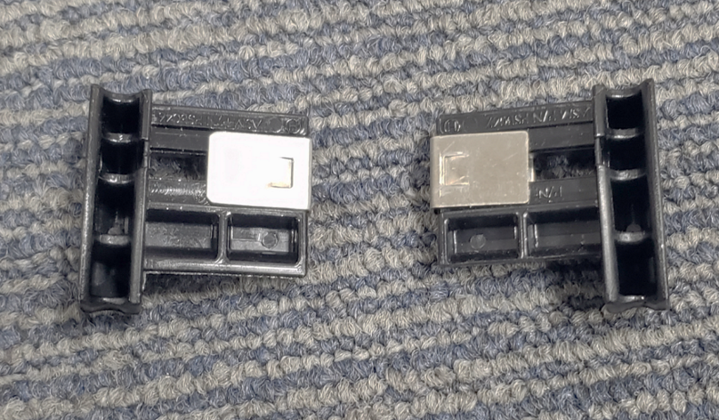
Figure 12 - Left and right slide guides
Insert the included slide guides into the sides of the adapter lath on the curtain. Gently tap them into place as shown in Figure 13.

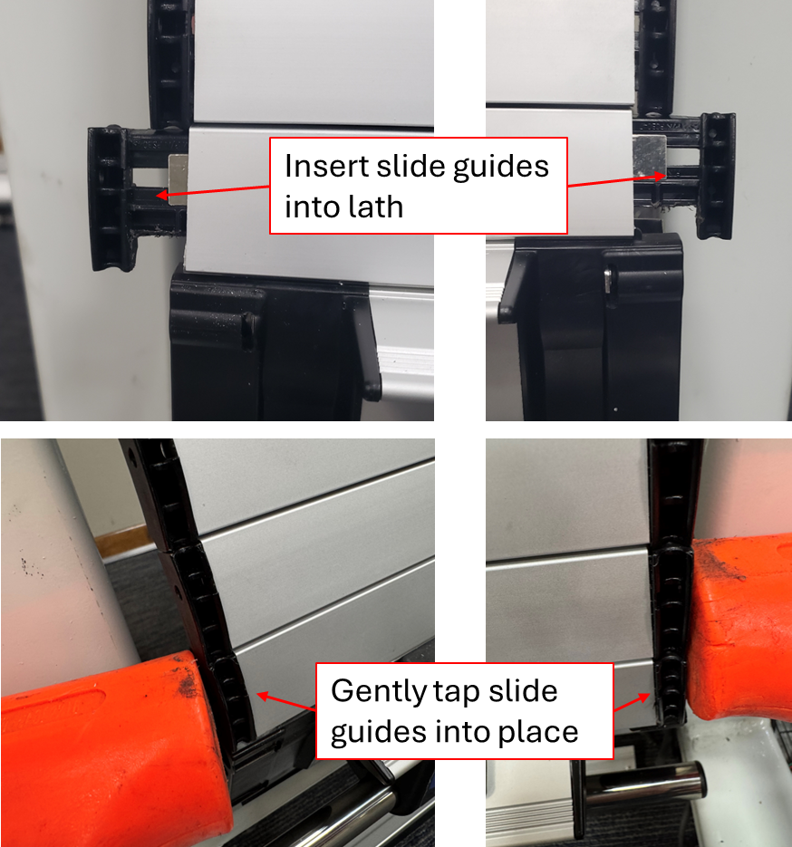
Figure 13 - Tap slide guides into place on the curtain lath
Removing the retaining pin from Figure 3 will release spring tension on the tube and the spring will act as a counterbalance to the weight of the curtain. When removing this pin, the installation technician should use a firm hand to pull on and maintain tension on top edge of the curtain to relieve spring pressure on the pin, making it easier to pull out. Use a suitable pair of pliers with sufficient grip. Larger doors may require two installation technicians to accomplish this task.
Gently release the spring tension on the roller tube with the hands and allow the curtain to wrap itself up on the roller tube.
Watch fingers for pinch points during this step. Use of suitably protective work gloves is strongly recommended.
**WARNING**

THE ROLLER TUBE ON YOUR DOOR COMES FROM THE FACTORY WITH A PRESET AMOUNT OF SPRING TENSION FROM AN INTERNAL TORSIONAL SPRING. FAILURE TO RELEASE THIS TENSION IN A CONTROLLED MANNER CAN RESULT IN PERSONAL INJURY AND DAMAGE TO YOUR ROLL UP DOOR. DO NOT ATTEMPT TO ADJUST THE TENSION ON THE ROLLER TUBE AS IT COMES PRESET FROM THE FACTORY.

Step 5 – Guide Channel Installation
Slide the guide channels with side seals onto the sides of the curtain. Note that the guide channels are handed. The large, rearward facing chamfered end of the guide channel goes at the top of the vehicle compartment facing inward. With both guide channels on either side of the curtain, gently lower the curtain into the opening until the front flanges on the guide channels rest against the front face of the vehicle body (Figure 14).

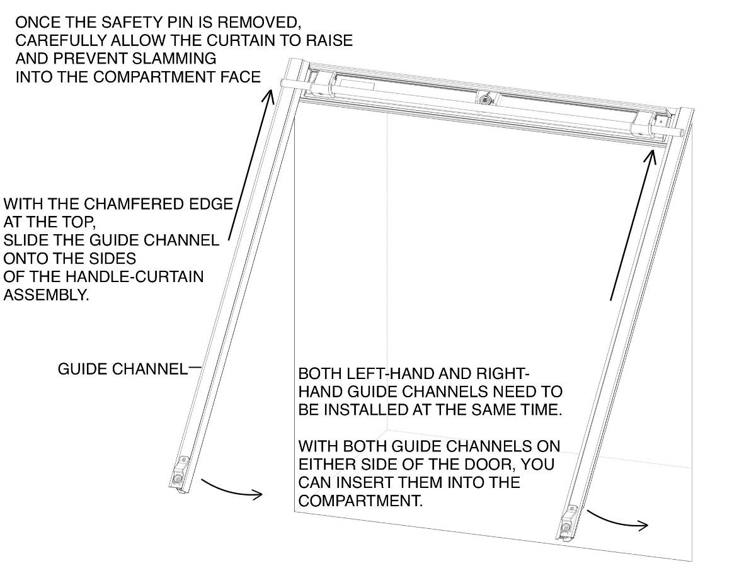
Figure 14 - Installing the guide channels (bottom sill not shown)

Now raise the door fully (Figure 15). The curtain should coil freely around the roller tube.

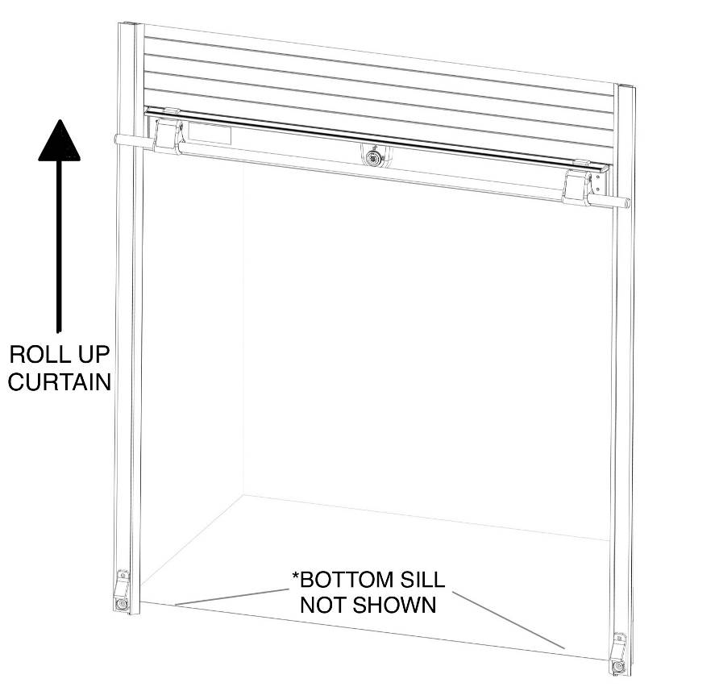
Figure 15 - Raise the curtain to install fasteners for the guide channels
NOTE: If installing the lit handlebar option, DO NOT install guide channel fasteners at this time. Complete the lit handlebar installation as detailed in “SECTION 2 – Optional Features” and then proceed to the next step.
With the curtain open, secure the guide channels to the sides of the vehicle compartment with #8 sheet metal screws or other fastener suitable for the material and thickness of the body. These should go down in the recessed slot provided in the guide channels (see Figure 16). The heads of the fasteners must not protrude above this slot or rough operation of the door will be the result. Note that if your Roll Up Door has the locking feature shown in these illustrations that a 1/8” diameter hole will be pre-drilled about 2 inches from the bottom of each guide rail. These are pilot holes for drilling the intercept holes for the locking rods and must be kept clear for the final installation steps.

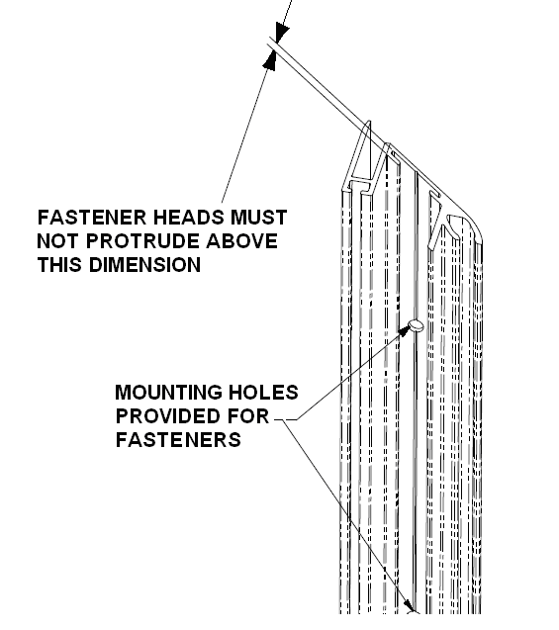
Figure 16 - Securing the guide channels

Step 6 – Drip Rail Installation
If your Roll Up Door includes the optional two-piece top seal, the adhesive backed rubber seal must be applied to the curtain before securing the drip rail to the body. Fully close the door and temporarily hold the drip rail and top seal in place. Use a light pencil mark or temporary piece of tape to locate where to install the rubber seal on the curtain so that it intercepts at least one of the fingers of the extruded portion of the top seal when the door is closed. (See Figure 17). Do not apply the adhesive backed seal across the crack between the door curtain laths. If you have the single piece top seal, you may proceed without this step.
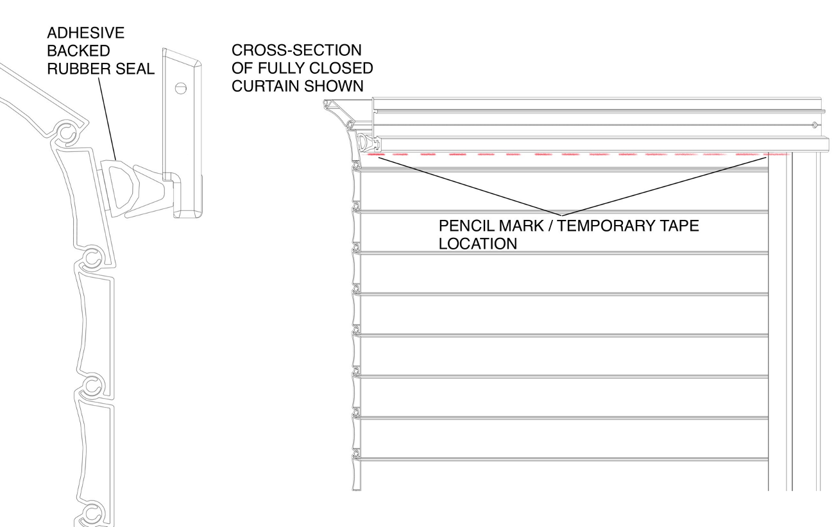
Figure 17 - Top seal types and configurations
A groove for locating drilling points is provided in the drip rail (see Figure 18). It is recommended that this be done using drill bits with stops on them, and that the door closed and latched to ensure the bit does not scratch the visible face of the door. Drill starting holes for a 3/8” long sheet metal screw (#8 recommended). Screws longer than this may damage the seal or scratch the door. A spacing of between 12 to 16 inches is recommended for fasteners. The mounting surface of the drip rail should have some silicone sealant applied around the mounting holes to aid with water resistance.

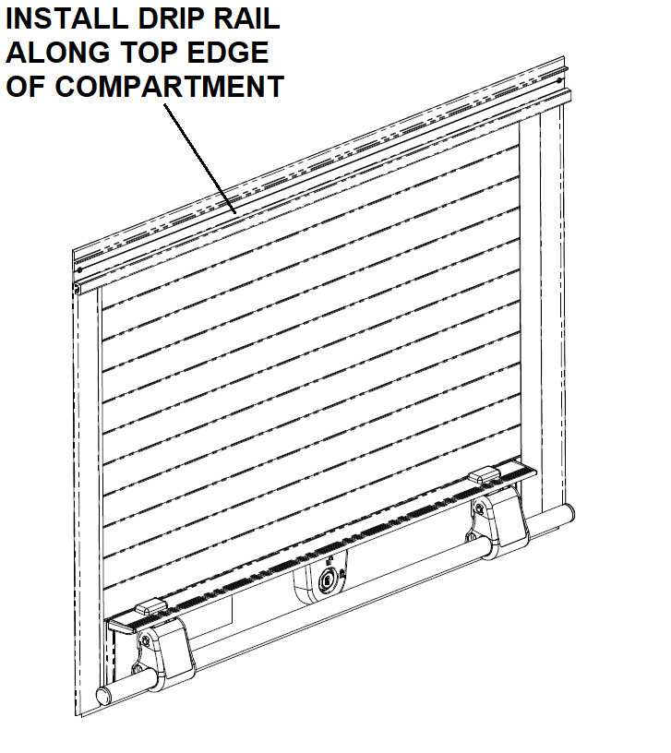
Figure 18 - Drip rail installation
Note that the “step” in the drip rail laps over the top of the guide channels. Trim the top seal in the drip rail to fit in the remaining opening between the guide channels and trim the side seals on the guide channels to butt up against the top seal in the drip rail. (See Figure 19 and Figure 20).

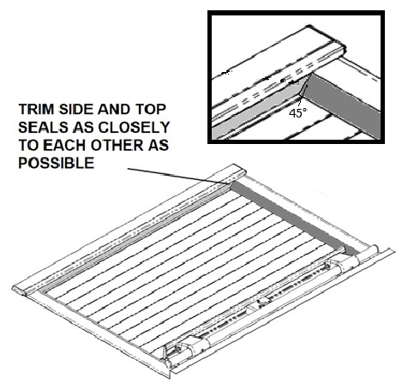
Figure 19 - Trim top and side seals to fit
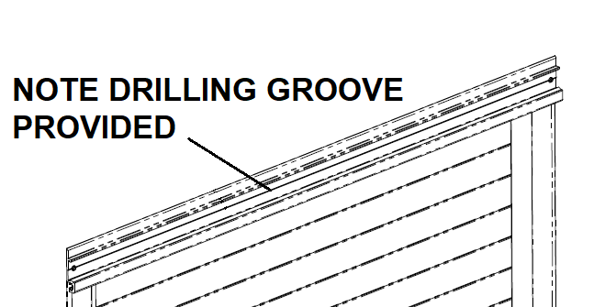
Figure 20 - Drilling guide for drip rail
If your drip rail includes the optional cover plate, the cover must be installed by sliding and tapping it in from the side. Use a soft block of wood against the aluminum extrusion to avoid denting or scratching it. After the cover is in place, the end caps may be tapped into the end in the same manner as the cover. Notice that the end caps are handed left and right, and that the hole in the back side of the end caps tongue section mates up with the dimple in the drip rail. (See Figure 21)
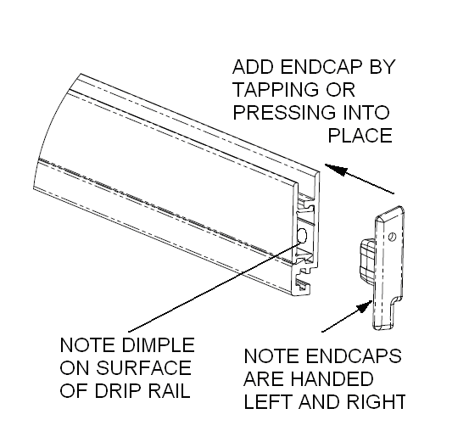
Figure 21 - Optional drip rail cover plate and end caps

Step 7 – Final Assembly
If your Roll Up Door includes the 2-point locking feature as shown in the illustrations, use the provided 1/8” dia. pilot holes to place a small amount of modeling clay or plumbers putty. Close and latch the door and attempt to lock it. In doing so, avoid applying excessive downward pressure to avoid a bias. This will mark the putty precisely. Use a 3/8” drill at this mark to drill out the locking rod intercept holes. When the holes have been drilled, close and latch the door and test the locking rods for proper functionality. If any resistance is encountered by the locking rods, enlarge the holes slightly until proper engagement is achieved. (See Figure 22)

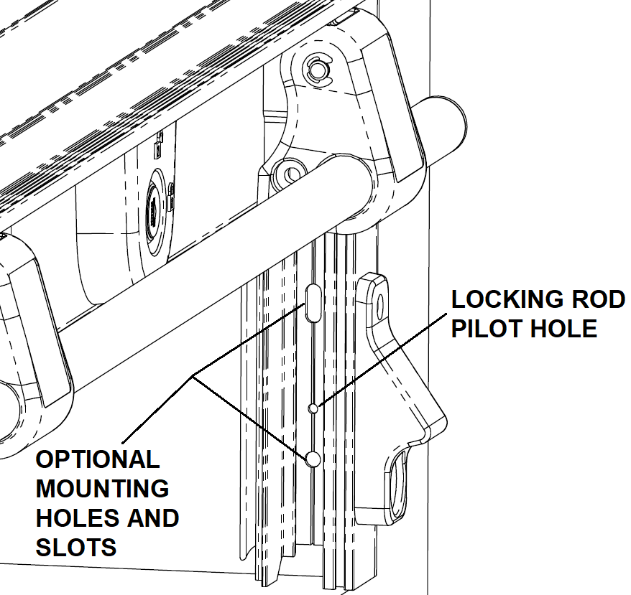
Figure 22 - Locking rod intercept holes

SECTION 2 – Optional Features

Door Ajar Switch
If your Roll Up Door kit includes the door ajar switch and LED light tubes, now is the time to connect them to your vehicle’s power supply. Be sure not to reverse the polarity on the LEDs or they could burn out. Refer to Figure 23 and Figure 24 for the particulars of the door ajar switch.
It is strongly recommended to use split sheathing (not supplied) to cover any exposed wiring, especially when routing it through cutouts in the compartment walls of the vehicle. Unlatch and raise and lower the door several times to check the functionality of the compartment lights and the switch.

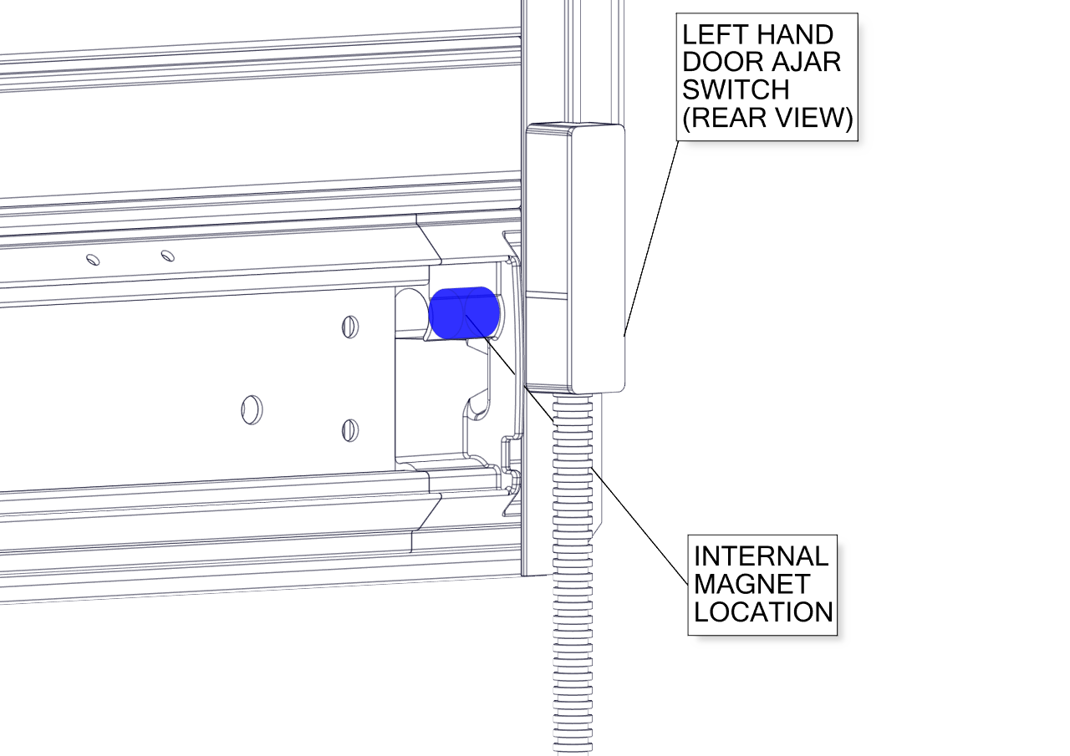
Figure 23 - Door ajar switch location

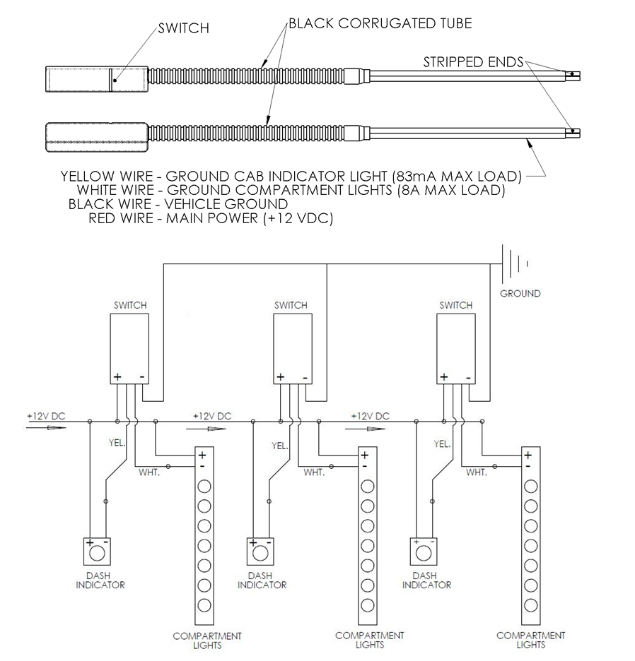
Figure 24 - Door ajar switch wiring

Bungee Strap
If your Roll Up Door includes a bungee strap, the free end bracket should be mounted to the compartment side wall using a screw or bolt and suitably sized washer (not provided) just underneath the bottom edge of the roller tube mounting plate as shown in Figure 25.

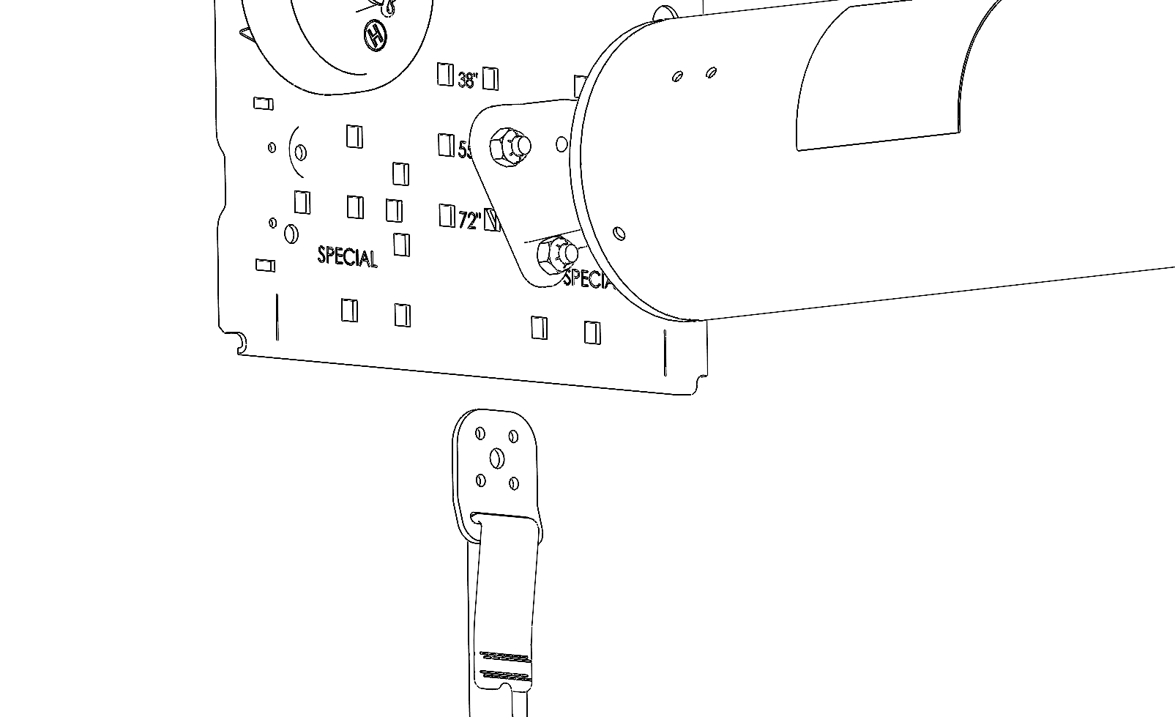
Figure 25 - Bungee strap installation

10mm LED Compartment Lights
For 10mm LED snap in light tubes, the easiest way to install them is to start the molded plastic end cap into the channel by snapping it in at an angle as shown in Figure 26. Placing the palm against the outside face of the guide channel, the rest of the light tube may now be progressively snapped in using finger pressure. Snug the screws down into their bosses to secure the lights permanently.

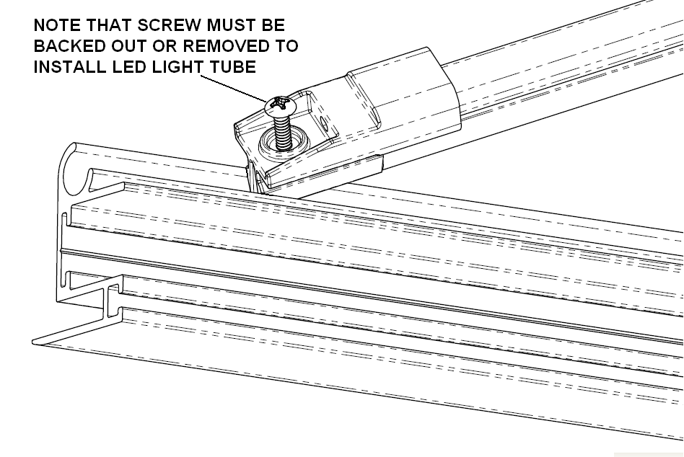
Figure 26 - LED light tube installation
To remove the light tube in the unlikely event that a replacement is needed, simply back the screws out as shown, and using a large, flat bladed screwdriver tip underneath the edge of the molded end cap, pry one end of the tube free, then pull the rest of the tube out by hand, taking care to avoid injury by banging against any compartment contents or shelving.
For RGB light strips, see Figure 27 for wiring / color combos.

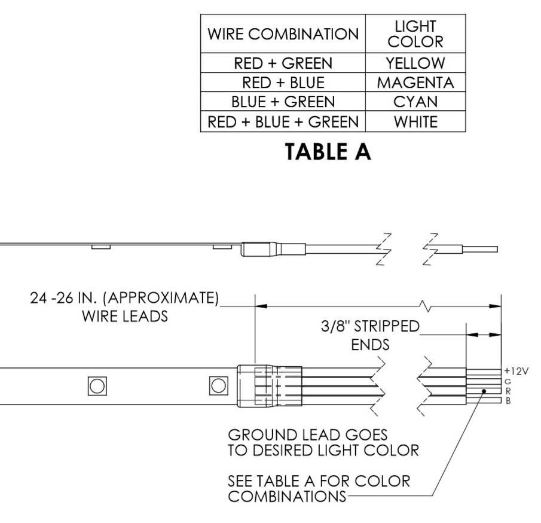
Figure 27 - RGB multi color light strips

Drip Pan
For the optional drip pan, a printable drilling guide is located in APPENDIX A - Drip Pan Drilling Guide and should be aligned to each mounting plate as shown in Figure 28 to locate the holes for the drip pan bracket. Be sure to check the dimensions provided for scale on the templates and the printers scaling factor when printing them out. For door heights that fall in between those listed on the drilling guide, discretion may be used to mount the drip pan a little closer to the curtain roll if so desired. It is not advisable to leave less than 0.50” clearance between the rolled-up curtain final maximum diameter and the drip pan. Secure the drip pan brackets to the compartment walls with the PEM studs facing down as shown. Use 3/16” self-tapping fasteners (recommended, not provided) suitable for the thickness of the material in the compartment wall. Using the cap nuts and lock washers supplied in the kit, secure the drip pan to the brackets and check again for clearance with the curtain roll.

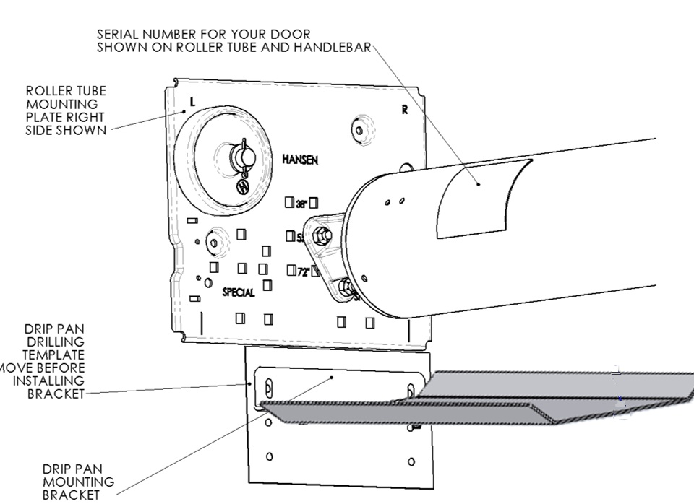
Figure 28 - Drip pan installation

Lit Handlebar
For the lit handlebar accessory, the cable shield will be installed behind either the right side or the left side guide channel, depending on which orientation was ordered. The handlebar will also have the mating sensor bracket preinstalled.

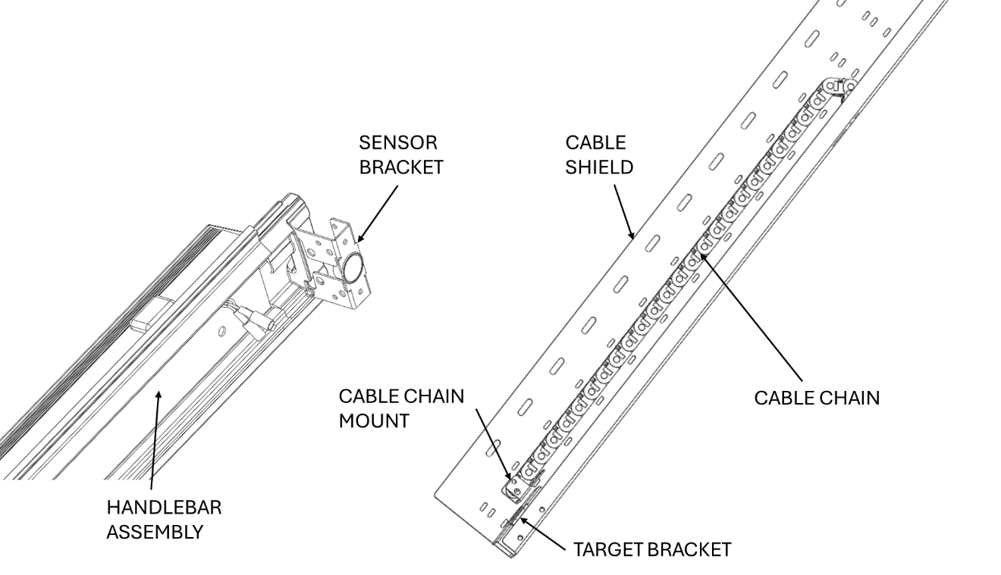
Figure 29 - Lit handlebar assemblies
Slide the cable shield behind the appropriate guide channel. Position it ¾” above the bottom of the door. (See Figure 30). Fasten the guide channel and cable shield to the compartment per the instructions in Step 5.

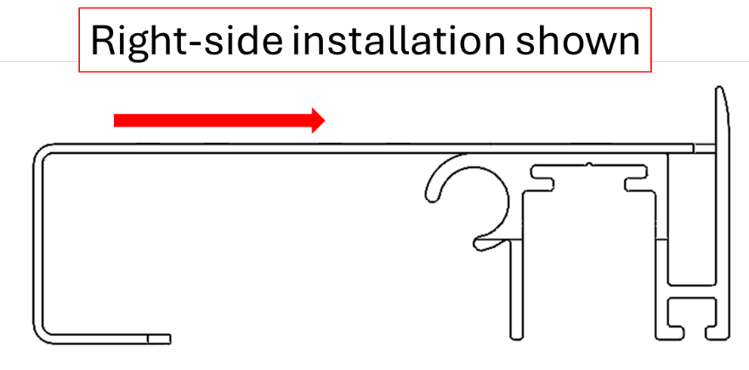
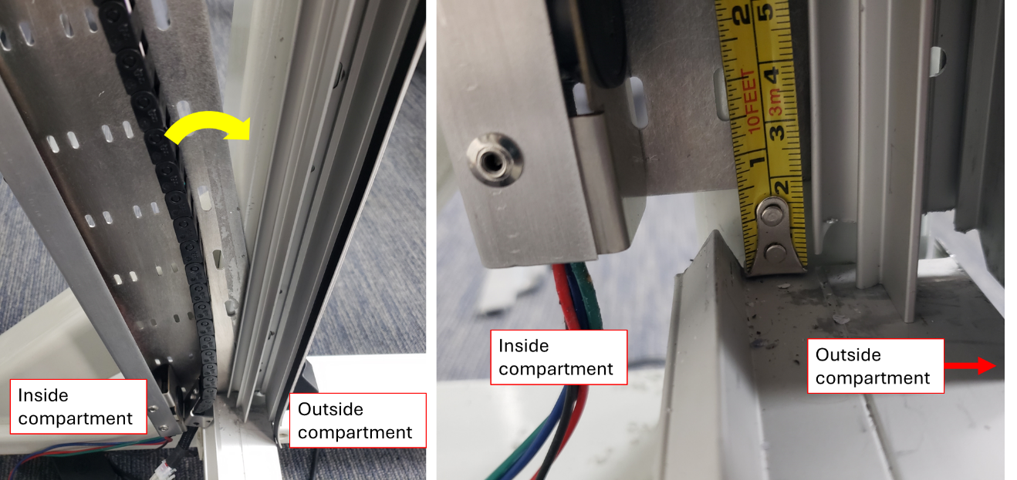
Figure 30 - Install cable shield
Slide the cable chain mount around the top of the sensor bracket and secure in place with the 2 supplied fasteners. Refer to Figure 31. Note that the chain bracket sits in between the cable chain mount and cable chain.

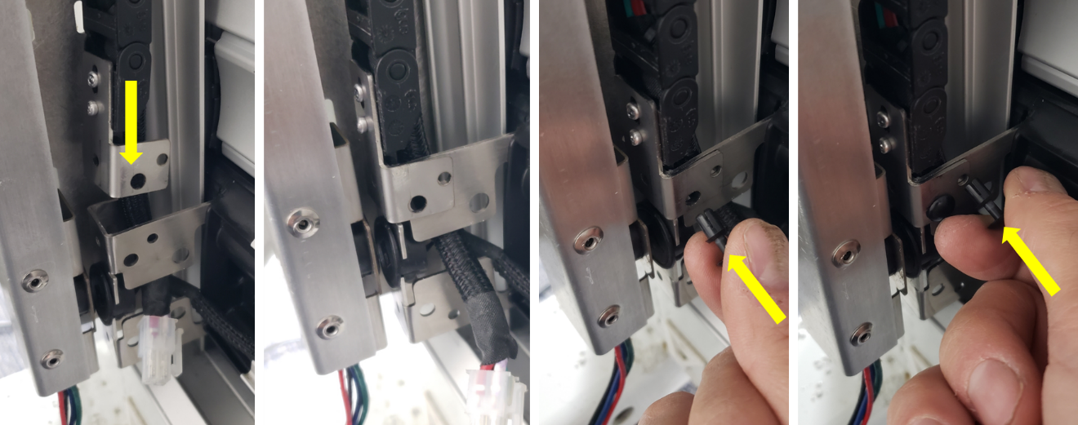
Figure 31 - Securing the cable chain mount to the chain bracket

Connect the handlebar light electrical connector to the mating electrical connector on the cable spacer, as shown in Figure 32.

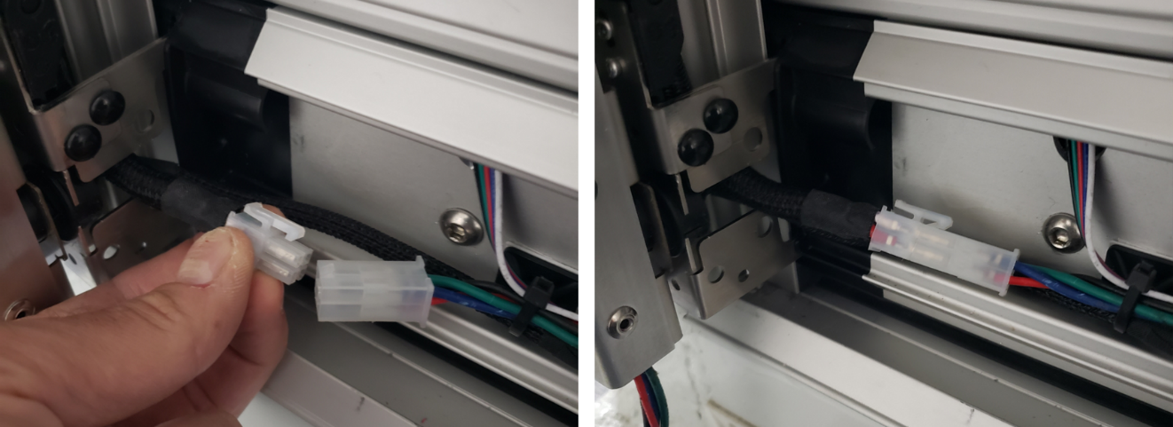
Figure 32 - Electrical connectors for the lit handlebar
Snap the protective cover plate into place on the back of the handlebar, covering the handlebar cabling as shown in Figure 33.

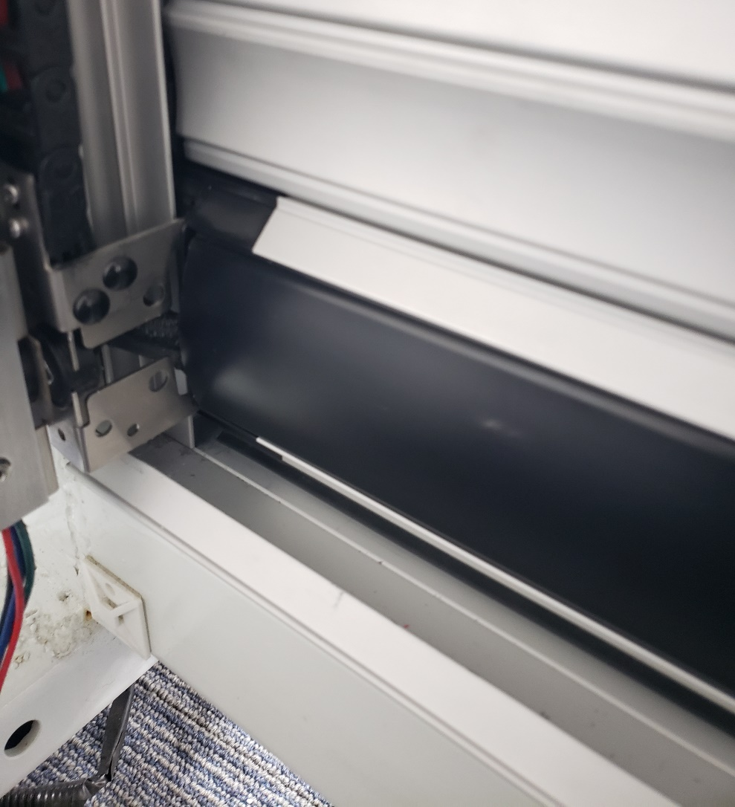
Figure 33 - Installing the cover plate

Connect the red and black power cable leads to the vehicle electrical system. (See Figure 34).

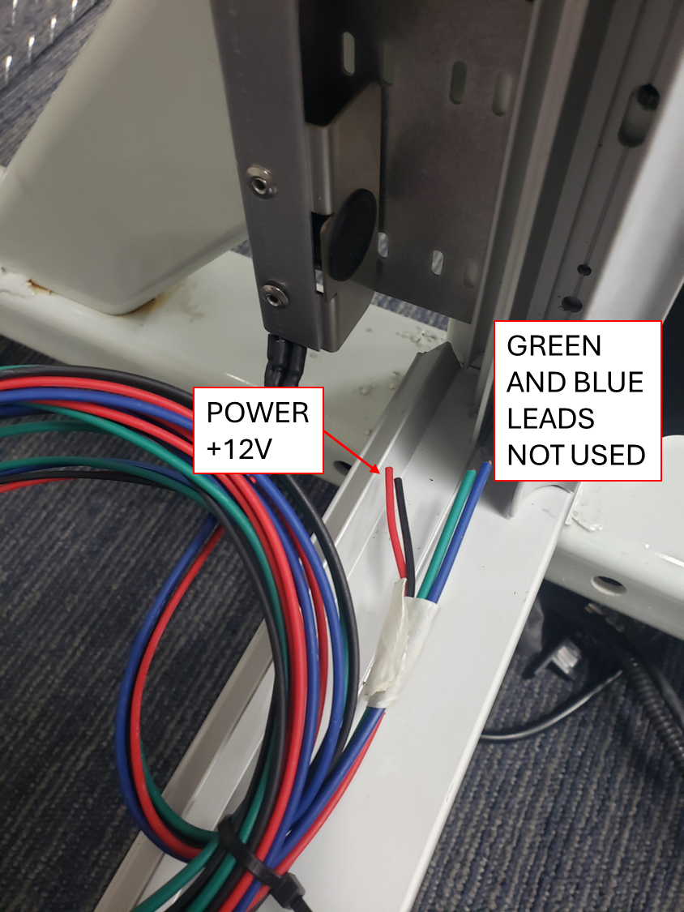
Figure 34 - Wiring to the power system
Refer to Figure 35 for the lit handlebar wiring diagram.

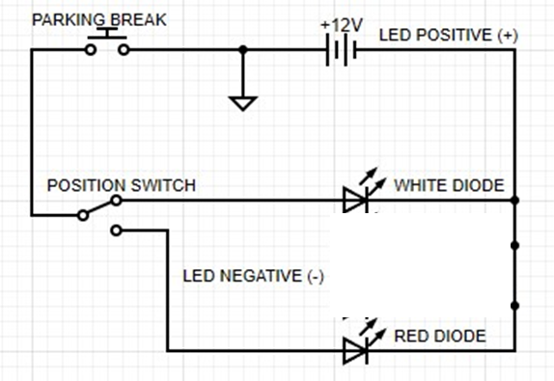
Figure 35 - Lit handlebar wiring diagram

SECTION 3 - Care and Maintenance

Although the aluminum components of your door are hard anodized for protection from the elements, it is important to periodically clean your Roll Up Door assembly, not only to wash away acids or salts from local road treatment and air quality, but to remove grime and road dust that can accumulate and affect smooth operation and increase wear on moving parts. In addition, grit and dust accumulation on the exterior surfaces of the door can lead to scratching or dulling of applied paint and decals on the curtain exterior.

Exterior surfaces of the curtain should be cleaned with a mild detergent solution. It is not recommended to use pressure washing devices as these generate forces that can damage the soft seals around the edges of the curtain. The tracks in the guide rails should be kept clean and free of grit and salts. Use the same detergent solution and a clean cotton cloth or soft nylon bristle brush to thoroughly clean the tracks in the guide channels. In case of heavy contamination by dirt or grit, it may be necessary to remove the guide channels and clean the wheel carriers on the latch lath and the individual end caps of each lath in the curtain. Frequent inspection and cleaning (when necessary) will minimize the need for this and extend the life of your Roll Up Door.

If lubrication of the tracks is desired, it is recommended to use only a drying type lubricant such as graphite or silicone spray. Use of grease or oils will serve only as a magnet for grit and will eventually make operation more difficult and accelerate wear.

Check frequently to make sure the handle bar is operating smoothly and locks positively underneath the handle bar keepers, and that the keepers remain tightly riveted to the guide channels.

APPENDIX A - Drip Pan Drilling Guide

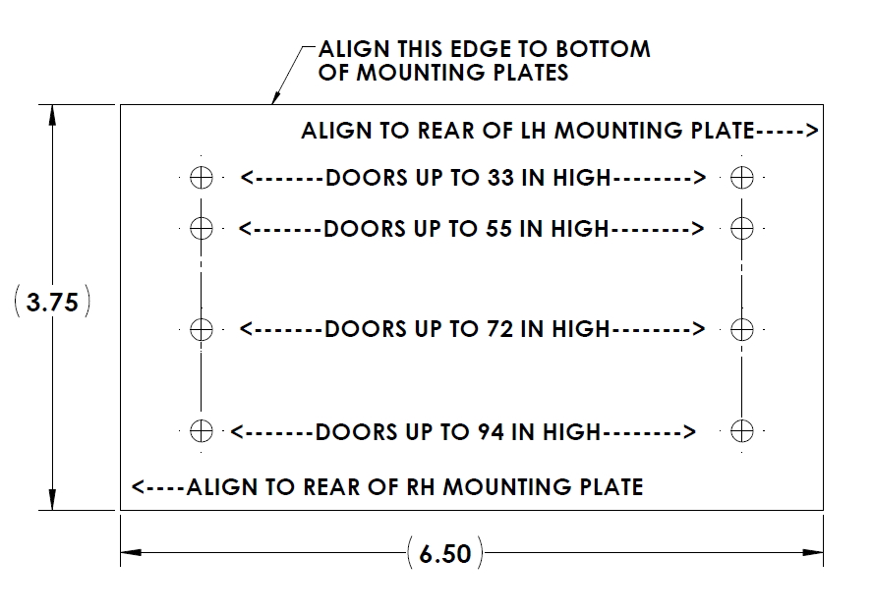
Figure 36 - Drip pan drilling guide

